Table of contents
1. Purpose 1
2. GQM table 1
3. Reporting of planed and actual individual effort log data of K15T1_Team11 week 3 1

Purpose
This document provides the information about measurement of schedule to support PM make decision to meet business goals of project

GQM table
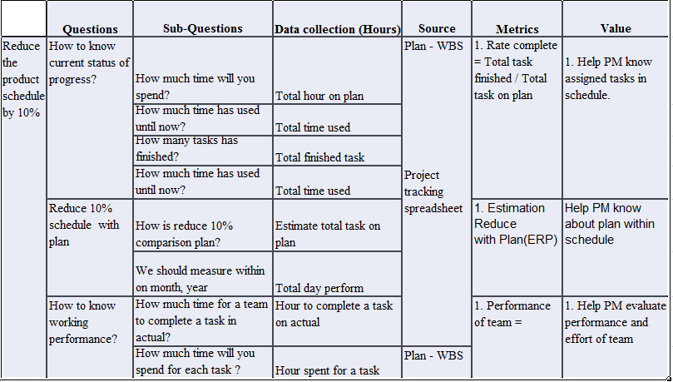

Reporting of planed and actual individual effort log data of K15T1_Team11 week 3
References attachment: “K15T1-Team11-TA1-TeamEffortLog.xls” on Sheet “ Analysis and Conclusion” week 3
